GODALMING BAND BULLETIN, OCTOBER 2014

Dear Readers,

I hope you enjoy this issue of the Bulletin with news of the Bands’ activities. The Youth Band has been especially active this summer, as seen below.You will find here information on engagements, recent achievements, and brief activity reports.
David Daniels, Editor

CHAIRMAN’S MESSAGE

Hi everyone and welcome to our Autumn Band Bulletin. Our bands have enjoyed a successful summer season with the Senior Band filling engagements at fetes in Church Crookham, Shamley Green, and Cranleigh as well as two concerts on Godalming Bandstand. The concert in Woking Park was unfortunately abandoned due to torrential rain. Wonersh Songs of Praise was another summer highlight.
During August the Youth Band undertook two most enjoyable engagements as part of Godalming’s Staycation week – as reported below. September saw our bands actively engaged in the Godalming United Church open day, a bandstand concert and Armed Forces day, all raising our profiles in the local community.
Now after a truly beautiful period of late summer sunshine we are looking forward to the Autumn season and (dare I say it!!) the Christmas events. Details are listed below. Thank you for your continued interest and support of our bands and we hope to see you at the Mayor’s concert this month.
Ray Pont, Band Chairman

SENIOR BAND

MAYOR OF WAVERLEY’S CHARITY CONCERT

Waverley Mayor this year, Councillor Liz Wheatley, and a great friend of the Band, has invited the Senior Band to join forces with Godalming Operatic Society to raise funds in support of the local branch of the Citizens’ Advice Bureau. This event will take place on Saturday 18 October in Charterhouse Great Hall at 7.30pm.
The programme will include well known songs from Gilbert and Sullivan performed by GOS, while the Band will play a varied programme, including a newly commissioned piece for trombones.
Please come along to support the Band and this charitable cause. Tickets may be ordered from the CAB through the website listed under upcoming events.

WW1 COMMEMORATION

2014 is the centenary of the outbreak of WW1. Over the next four years a series of commemorative events will take place locally.
Two short public services on 4 August marked the War’s start.
The first was held outside Farncombe Day Centre/Parish Church. A time clock plaque was unveiled listing the names of local men killed in the War, set out in date order. Later that day a similar event took place in the Parish Church of St. Peter and St. Paul. A copy of the clock has also been placed under the Pepperpot. Both events were very well attended. The Band was represented by Chairman Ray Pont and Keith Rowling, who played the last post and reveille.

LOOKING TO THE FUTURE

At the end of September we were delighted to welcome four youngsters from the Youth Band, Matthew, Danny, Charles and Issie, to a Senior Band practice. They continue as key members of the Youth Band, but sitting in with the Senior Band is part of their musical development, which has been so brilliantly cultivated by David Loftus.

CHRISTMAS CONCERT

Our annual Christmas concert will be held at the United Church in Godalming. The date is Saturday 13 December, starting at 7.00 pm, and will feature both bands. Make sure to put this in your diary!
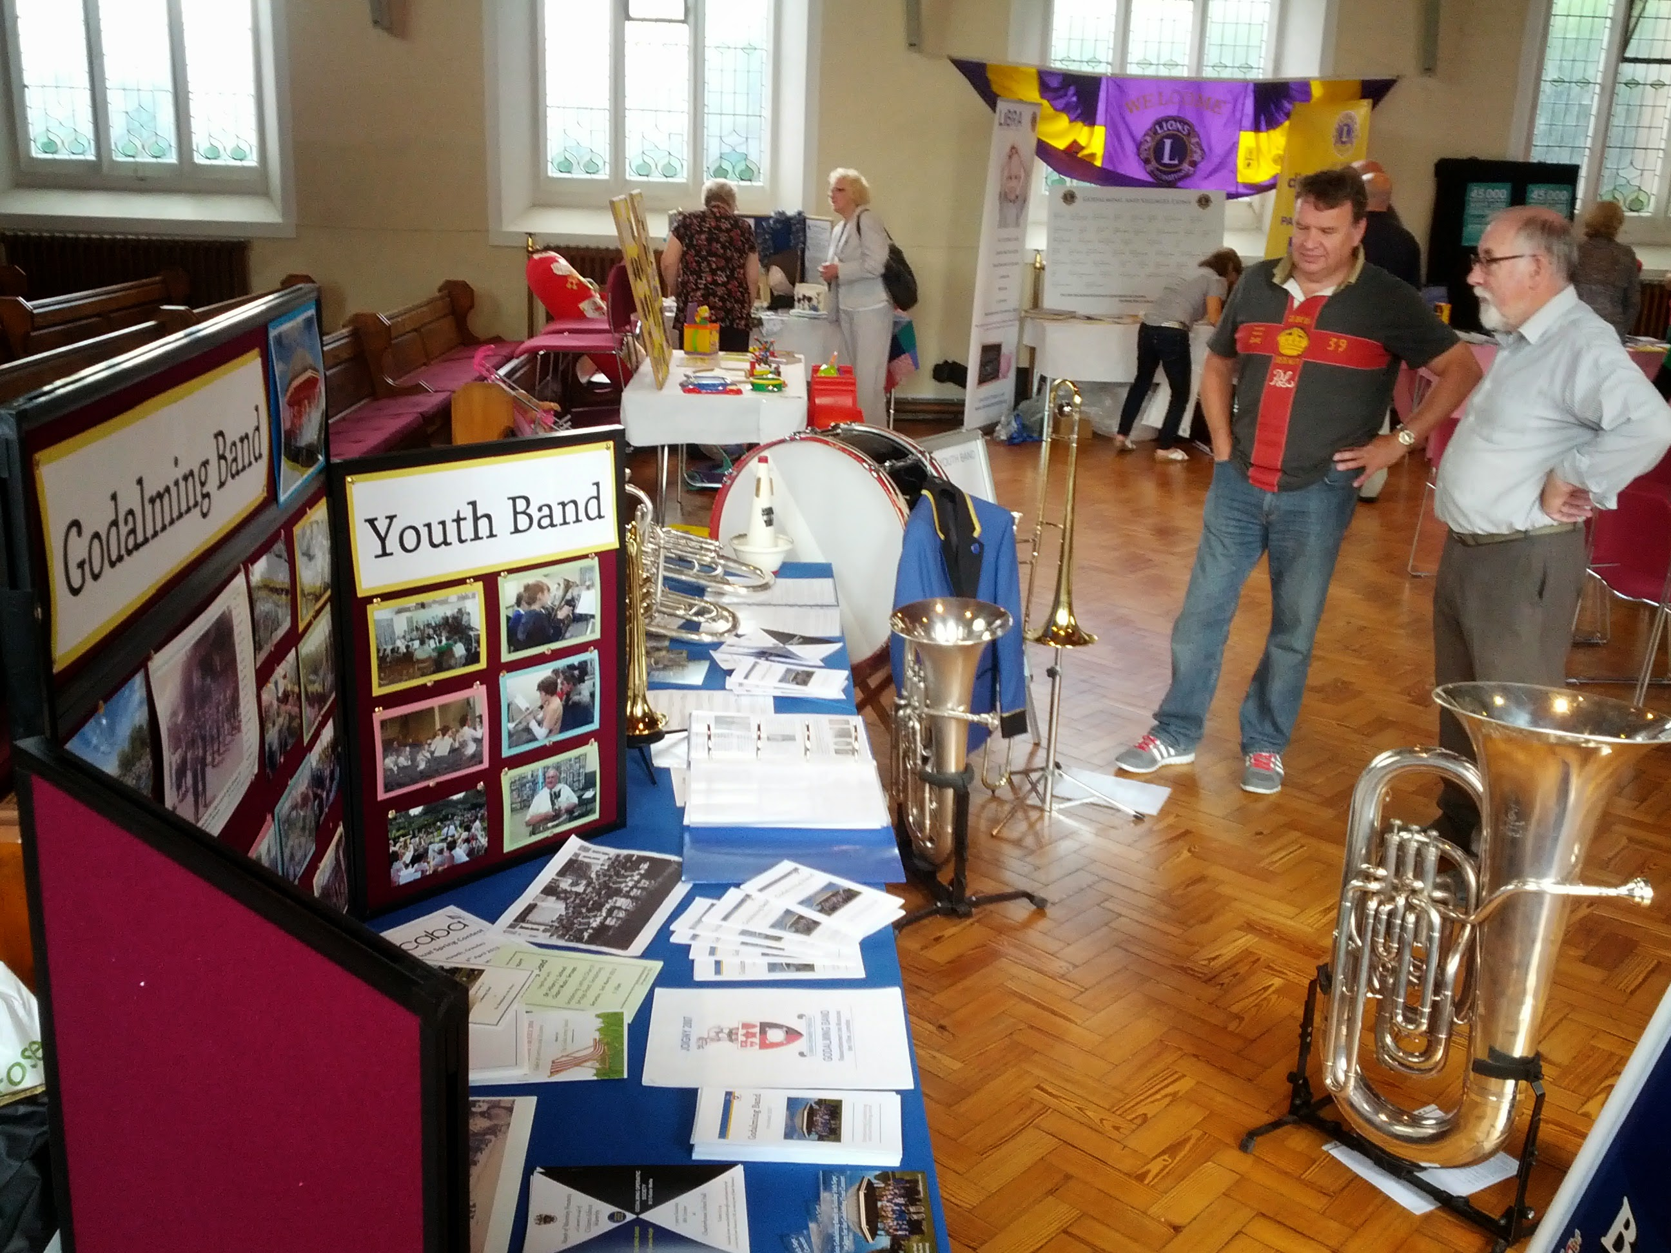

Heritage Day display, Godalming United Church

As part of the national Heritage Day weekend, Godalming United Church invited the Senior Band and Youth Band to exhibit and play at their showcase event held on Saturday afternoon, 13 September. This was an opportunity to celebrate the many groups that are linked to the church and use its facilities.
The Youth Band played two half hour slots in the afternoon in front of the church, with a crowd of passers-by drawn in by the music. Inside, a display was set up exhibiting the Band’s history (see photo above), excerpts from the Band’s museum exhibition, and samples of the various events that make up the Bands’ engagements diaries. The older photos and documented history proved particularly interesting to long-time Godalming residents, and those who had links to the Band.
A range of instruments from bass to cornet was available for visitors to have a blow on, and we hope that seeing and hearing kids play with the Youth Band will inspire some future players for the group.
Thanks go to Band members and helpers who came along to set up the display and assist the Youth Band. We also must thank Godalming United Church for inviting us. We look forward to participating again next year.
Dominic Cheal
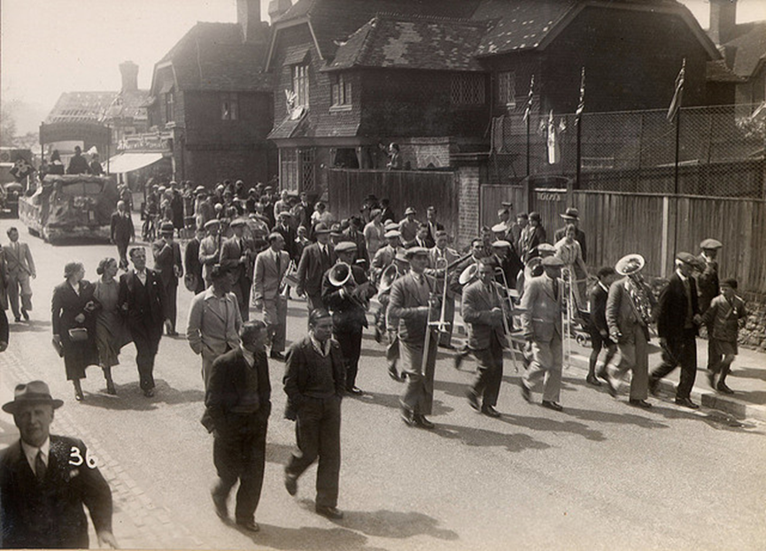
Godalming Band in 1937, playing for the Coronation celebration. This was their first outing, for which the Band was organised. The late Harry Coombes is in the middle of the front rank of trombones.

YOUTH BAND

STAYCATION
The Youth Band took up an invitation to join Staycation, which gives children the opportunity to try out different activities during the school summer holidays, and provided parents with many ways of keeping their children occupied. Our first stint was on Tuesday afternoon 5 August, a “Come and Try” session. Those members of the Youth Band not on holiday or otherwise engaged went along to Godalming Bandstand and gave an impromptu concert. Meanwhile Keith and Julie set up a table at the side of the bandstand with a range of instruments, and they were kept busy with a steady flow of children trying them out. A number of enquiries were made and details taken, resulting in Brendan Johnson starting on euphonium. Keith and Julie brilliantly managed the children on the “Come and Try” day and we are as ever grateful to the members of the Youth Band who turned up to perform. We achieved a mention in “The Messenger” as a result of our participation. We hope to do it again next year.

PRINCESS OF WALES’S ROYAL REGIMENT

Local supporters of the Regiment – the local County Regiment – organised a fundraising event on Saturday 20 September and invited the Youth Band to take part. It was a themed event with some performances, individuals or stalls reflecting the Second World War era.
We were asked if we could provide someone to play last post and reveille for an Act of Remembrance. Matthew Tate very ably took on this responsibility. The Band’s appearance was delayed by an hour, but the waiting did not detract from the Band’s performance. The forbearance of parents and members of the Band during the wait was greatly appreciated. An email of thanks was received with the possibility of a future engagement in support of the Regiment.

MUSIC FESTIVAL 2015

We hope to enter three classes again: Band – Open, Large Ensemble and Entertainment. A number of suggestions for themes have been made and are being considered. Unfortunately of the four possible dates two coincide with Broadwater School Activities Week, which will take away at least four of our members, making it impossible to participate.
As this is our local Music Festival it would be a disappointment not to enter. We can only wait and see if the scheduling of entries allows us to make our annual appearance at this event.

YOUTH BAND MEMBERS

We are pleased to welcome William Chantry (Cornet), Philip and Dennis Gueorguieva (Tenor Horn) and Brendan Johnson (Euphonium) but sadly Sam Warner (Trombone) has had to resign due to his educational work. Sam will be missed and we appreciate the time he committed to the Band.
If anyone knows of youngsters who may be interested in joining the Youth Band as beginners or who are already playing please contact Keith Rowling: 01483 428701, Andy Collins: 01252 702002 or David Loftus: 0208 8985509, or encourage them to pop in to the bandroom on a Monday evening between 6.00 and 7.50 pm.

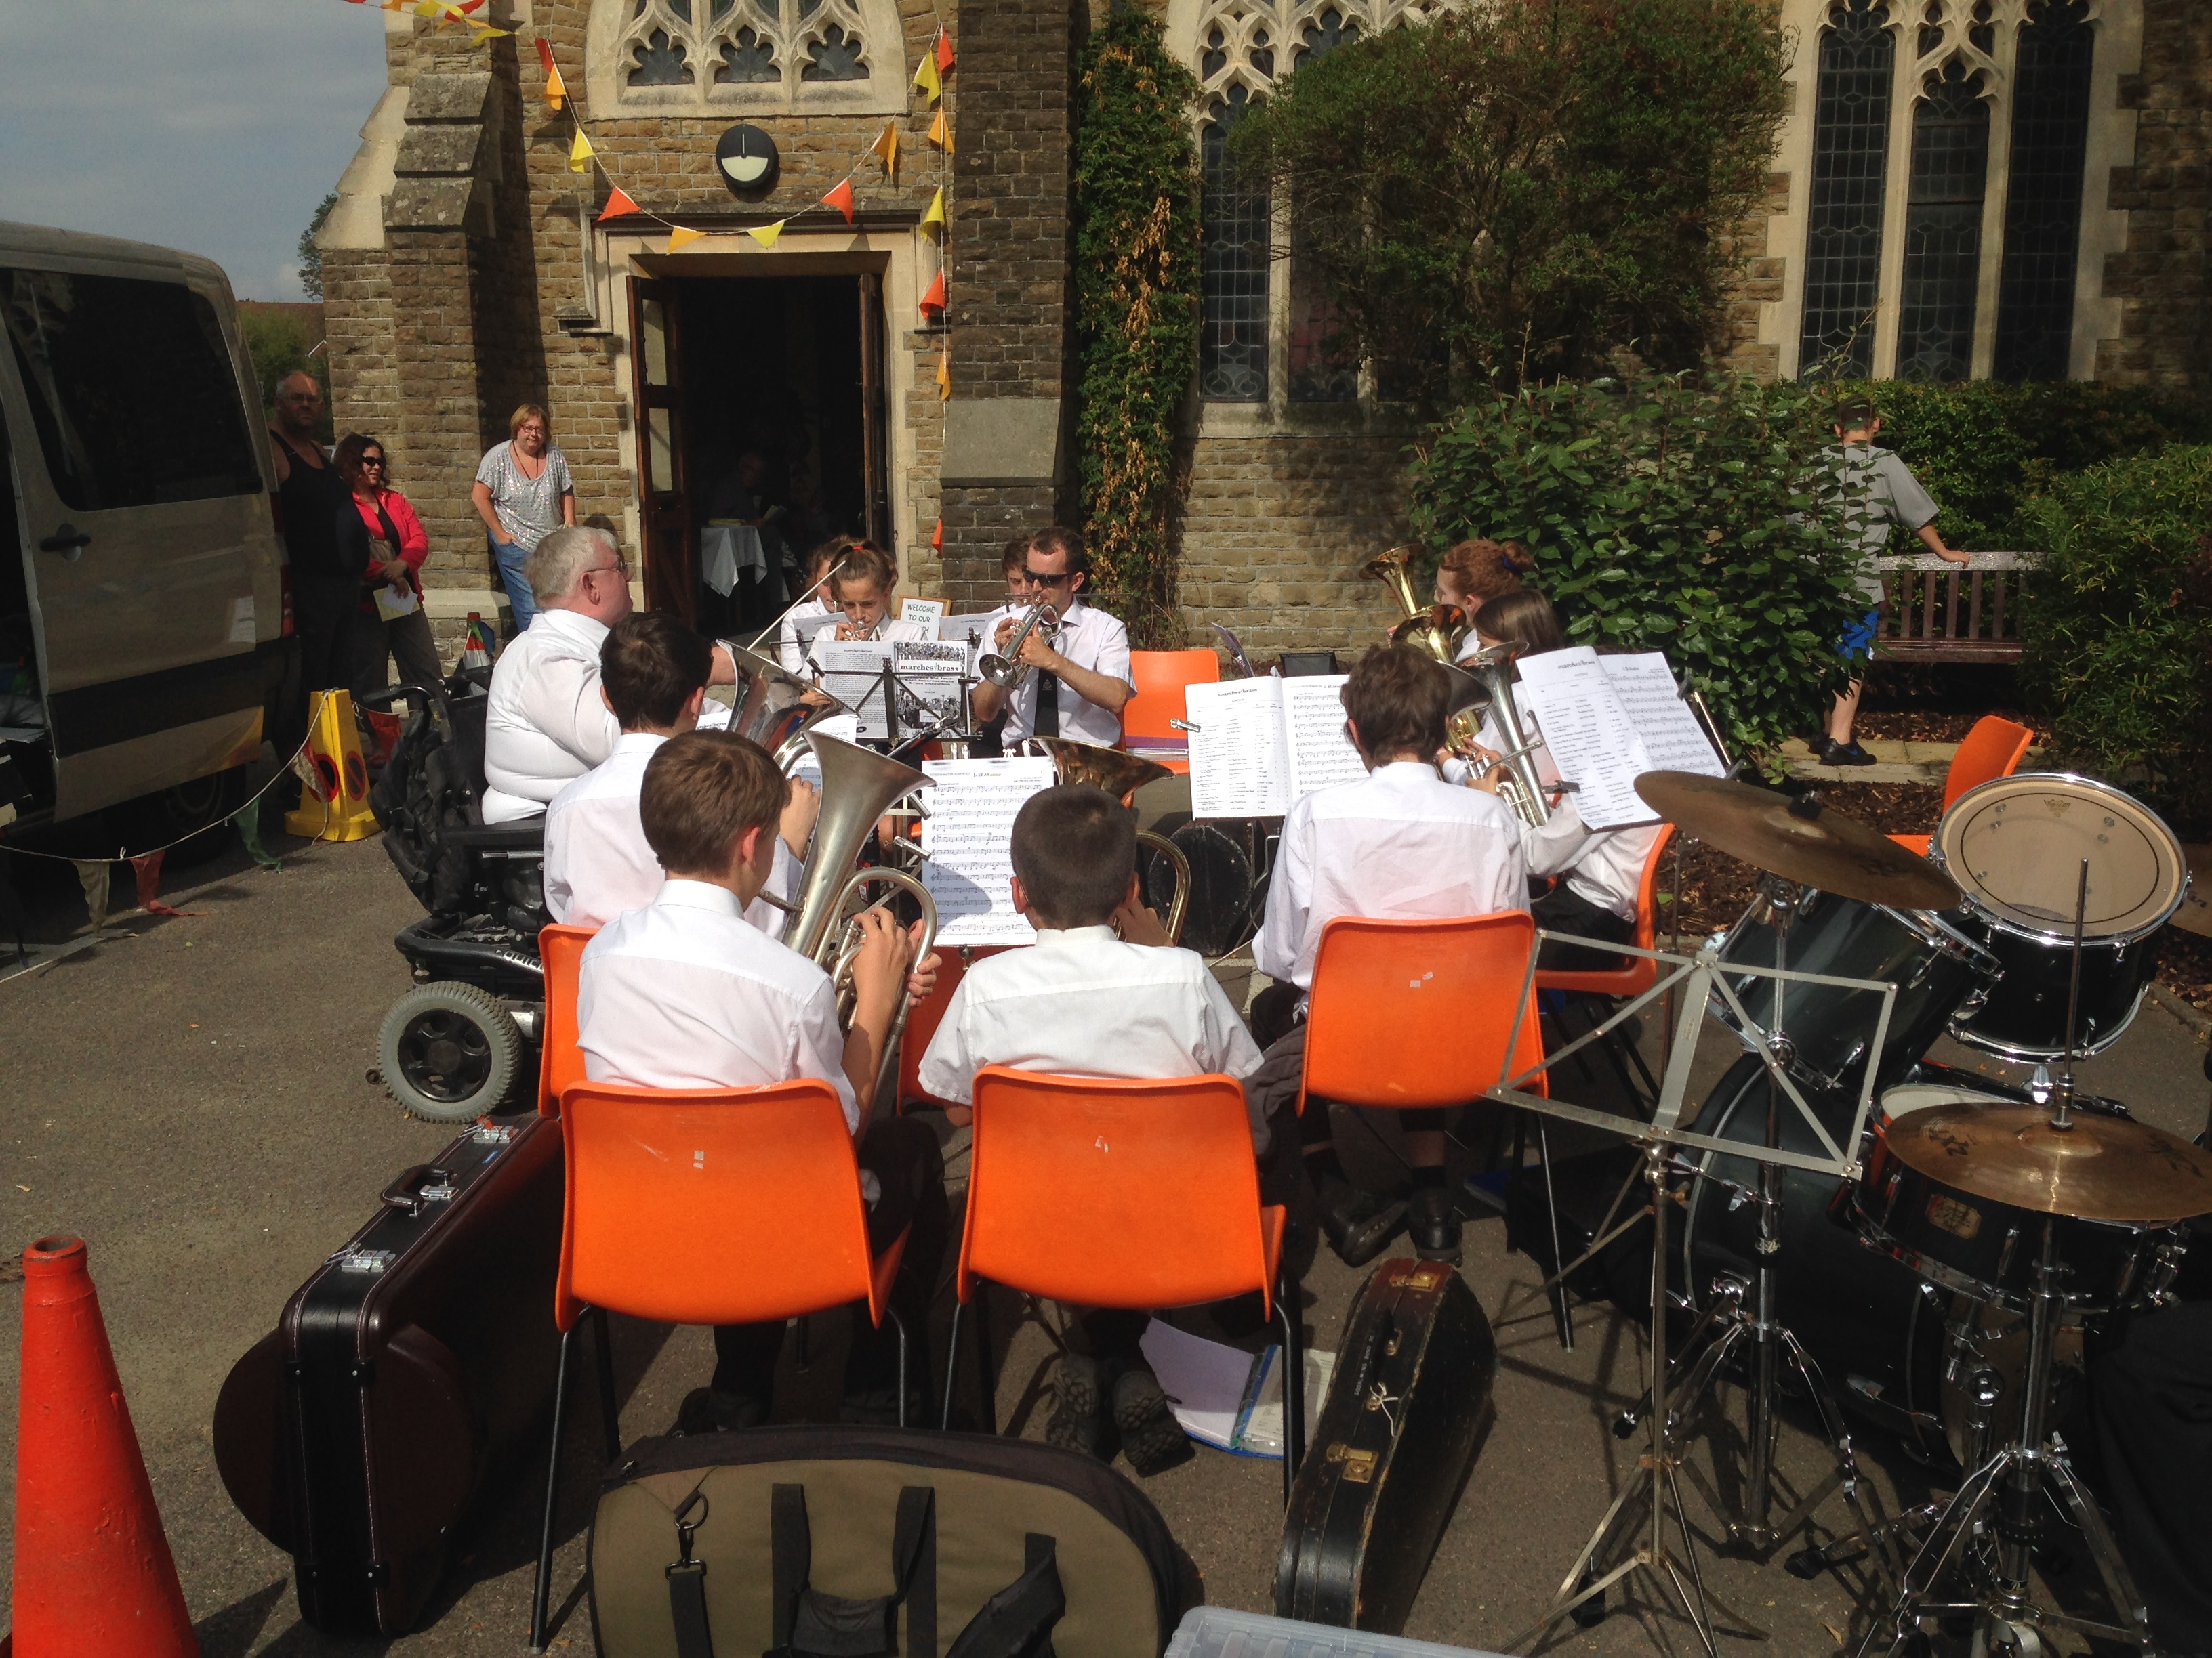
Youth Band playing at Godalming United Church on Heritage Day

GODALMING BAND MONTHLY DRAW WINNERS

Remember, you can always join the monthly Godalming Band
Draw. The chances of winning are presently one in thirty, a big improvement on the National Lottery’s one in fourteen million! Simply contact Julie Rowling at keithandjulie@rowling.plus.com for more information. Half the money raised goes to Band support.

March /April: no draw
May: The Alcrofts, Emma Schollar
June: Val Gardener, Louise Steele
July: George Robins, Charles Steele
August: Matt Newberry, Alison Sargeant
September: Val Gardener, Dave Sargeant

UPCOMING ENGAGEMENTS, SENIOR AND YOUTH BANDS

Saturday, 18 October Mayor of Waverley’s Charity Concert,7:30 pm
Charterhouse Great Hall. Tickets available online from Waverley CAB
(http://thelittleboxoffice.com/waverleycab)

Sunday, 9 November Senior Band, Remembrance Day Parade and Services, from 10.15 am

Saturday, 29 November Senior Band, Godalming Christmas lights
Pepperpot, 4 pm

Sunday, 30 November Youth Band, Elmbridge Retirement Village

Wednesday, 3 December Senior Band, carols, Godalming Masonic Hall

Saturday, 13 December Godalming Band and Youth Band Christmas Concert, United Church, Bridge Street, Godalming, 7.30 pm

Sunday, 14 December Youth Band, Eastlake Retirement Home

Friday, 19 December Senior Band, carols at Wonersh cricket ground, Wonersh
(map) http://goo.gl/maps/jvQqE

Saturday, 20 December Senior Band, carols, Godalming Town Centre 10.30 am – 1.00 pm – TBC

Sunday, 21 December Senior Band, carols, Valewood House, Haslemere 2.00 pm

Monday, 22 December Senior and Youth Bands, Godalming Waitrose carols, outside, 5.00 -8.00 pm -TBC

