**­­­­­­­­­­­­­­GODALMING BAND NEWSLETTER, MAY, 2012**



**CHAIRMAN’S CORNER**

Hi everyone and welcome to our Spring 2012 newsletter.

This is a very special year for all of us in many ways. Not only will we be celebrating the Queen’s Diamond Jubilee in June but also the Olympic/Paralympic games in July/September. However for those of us involved with Godalming Band, 2012 marks the 75th anniversary of the Band’s founding.

Over the past 18 months we have been working on ways to mark this very special occasion in the life of our Band. The weekend of July 14/15 has been set aside for our main celebrations. To help us do it in style the bands from Godalming’s twin towns, Joigny in France and Mayen in Germany, have been invited to come to Godalming for what will be a feast of music and a renewal of friendships. A full schedule of the events is set out below. We encourage you all to put these dates in your diary and make every effort to be with us to support the Band during what will be a memorable weekend.

We must not forget that our Youth Band has also been in existence for nearly 40 years and David Loftus is lining up some special events for them.

The Band website**, www. godalmingband.org.uk** will be updated shortly with details of all of these events.

Happy reading and here’s to a great summer of sunshine and music.

Ray Pont - Chairman

**C­­­­ELEBRATIONS**

On the June bank holiday weekend a series of special events is being organized by the Town Council to celebrate the Queen’s Jubilee. The Band will be actively involved, providing music for the lighting of the town beacon and grand fireworks display on Monday evening, 4 June. All of the Jubilee events are detailed on pages 29-38 of the *Queen’s Diamond Jubilee* booklet that has been widely circulated by Godalming Town Council.

A detailed description of our 75th anniversary weekend celebration, July 14-15, is presented below. We hope that you will keep these dates free in your diaries and join with us in celebrating 75 years of music and community service by our Senior Band.

For more information about these events please visit our website [www.godalmingband](http://www.godalmingband).org.uk. or contact the band chairman Ray Pont 01483 422174 .

During this coming months the Godalming Youth Band will also be holding some special events to mark some 40 years of banding and participating in the town’s Jubilee celebrations. Further details can be obtained from David Loftus, Youth Band MD, on 0208 8985509.



**SPRING CONCERT**

Godalming Band, St Hilary’s School, and Music Kids joined together for an entertaining concert at Godalming United Church Saturday evening, 3 March. Music education is a particular strength of St Hilary’s, as evidenced by several string groups and wind instrumentalists, as well as choral performers. Music Kids, United Church’s own youth singing ensemble, performed three uplifting songs which were well received.Godalming Band was in a light mood, presenting entertaining pieces with various soloists and solo groupings, along with novelty features. Haydn’s Farewell Symphony, played just prior to the interval, saw the Band gradually withdraw from the stage, leaving two musicians to finish. In the second half, Erich Siebert’s Bombastic Bombardon gave E flat bass player James Alcroft the chance to display his considerable musical talent.

St Hilary’s choir and Music Kids joined the Band in the final work, My Heart Will Go On, the Titanic film theme, recognising the special connections which Godalming has with the tragic sinking of that great ship one hundred years ago. Jack Phillips, a son of Godalming, was telegraph operator on the Titanic that terrible night.

Editor’s note: this article appeared in the **Surrey Advertiser** in March

**15 APRIL A DAY TO REMEMBER**

Godalming Band was privileged to take part in the moving commemorative service held at the refurbished Jack Phillips Memorial on 15 April, the centenary of the Titanic sinking. The Band provided several hymns and a fanfare to mark the reopening of the memorial. Following this event, the Band presented a bandstand concert drawn from works mostly of the late nineteenth and early twentieth centuries, reflecting the musical tastes of the time, and coordinating with the Titanic era. The day was clear, but cool and breezy, so one needed to secure music carefully to the stands. Given such a day, the turnout was respectable, and the Band enjoyed this excursion into the musical past.

**A VERY BUSY SUNDAY**

Sunday, 13 May, proved to be a hectic one for the Band. In the early afternoon, Penelope Keith, one of our patrons and a great friend of the Band, had asked us to play at a reception for her newly married son at her splendid Milford home. We were delighted to do so, and thoroughly enjoyed the occasion. We then moved on to Godalming bandstand for the inaugural concert of the Music in the Park season, drawing upon much of the music we had prepared for 15 April. This time the weather was with us – a warmish sunny day that brought out an appreciative audience. When the Band finished at 5pm, we had a real sense of accomplishment.

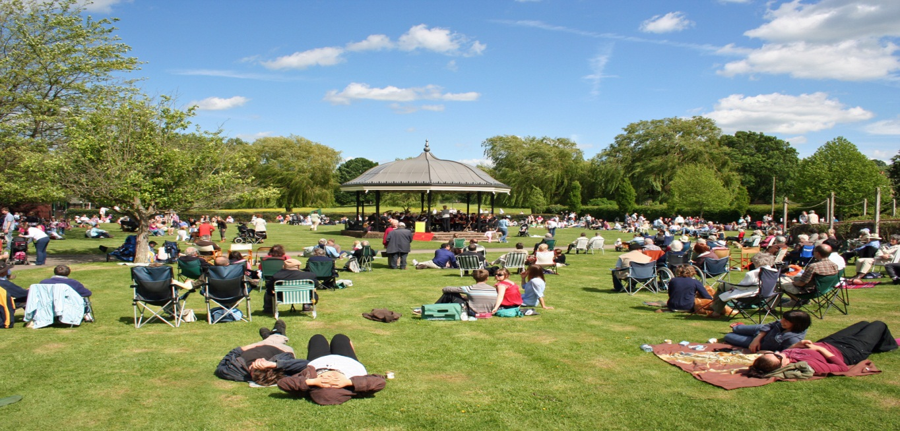

**Godalming Bandstand on a balmy Summer’s day, 2010**

**photo courtesy of George Robins**

**BAND ANNIVERSARY WEEKEND, 14-15 JULY, 2012**

For Godalming Band the most significant weekend this year is July 14-15, when we will host a series of special events to celebrate our 75th anniversary. The Band was formed in 1937 for the coronation of King George VI and Queen Elizabeth (the queen mum), so it is fitting that our 75th anniversary falls in the year when their daughter marks her 60th year on the throne.

Godalming Band has organised an international music festival with bands from Joigny, France and Mayen, Germany, Godalming’s twin towns, who will be joining us for this celebration. On Saturday morning the three bands will play a series of short concerts at various places in Godalming town centre. In the evening the bands will join together for a grand concert in the Ben Travers Theatre, at Charterhouse School. On Sunday afternoon the bands will parade through the town to the bandstand. Here our guests will share the platform with us for a concert of traditional band music. An exhaustive list of anniversary weekend events is below.

**Make sure to put these dates in your diary. Your enthusiasm and support will ensure a memorable weekend. If you have read this far, email me, please, at dwd112112@yahoo.com.**



**PAYING THE PIPER**

The upcoming Band anniversary weekend will stretch the Band’s finances, and we are extremely grateful for the financial help we have received from a variety of sources, including Surrey County Council (£1290), Godalming Lottery (£500), and several anonymous donors. The receipts from our Spring concert as well as income from our Quiz night on 18 May will bolster our balance sheet as well. Thanks again for everyone’s help.

**A COMPLETE LIST OF ANNIVERSARY WEEKEND EVENTS**

*­*

***Friday, 13 July***

Evening 5.00/6.00pm Joigny and Mayen bands arrive at Charterhouse School.

7.30/9.00pm Evening meal for visiting bands at Broadwater Community Centre.

Probable Civic welcome.

***Saturday, 14 July***

Morning 10.30am Joigny, Mayen and Godalming bands meet at United Church, Bridge Road, Godalming.

11.00/12.30pm All bands play three twenty minute street concerts in Godalming town centre (Pepperpot, Crown Court, Old Town Hall, opposite Waitrose).

1.00pm Visiting bands lunch in town.

3.00/ 4.30pm Joint rehearsal for evening concert at Ben Travers Theatre.

5.00/6.30pm Evening meal United Church, bands only.

7.30/10.00pm Joint evening concert, Ben Travers Theatre, Charterhouse.

10.00/11.00pm Post concert drinks/get-together.

***Sunday, 15 July***

9.30/12.30pm Free time – visiting bands have guided tour of Charterhouse School, Godalming or other places of interest.

1.00pm Visiting bands lunch in town.

2.15pm Bands meet at Wilfred Noyce Centre, Godalming.

2.30pm Bands march from Queen Street, through town to bandstand.

3.00/5.00pm Outdoor concert on bandstand.

Godalming will open the concert. Mayen and Joigny bands will each play their own programmes before a massed bands finale.

In case of bad weather, the concert will take place in a local church.

7.30/10.30 Outdoor barbecue/hog roast. Venue to be confirmed. Godalming Youth Band to provide some entertainment.

***Monday, 16 July***

Morning 9.00/9.30am Mayen Band departs for home. Joigny Band and Twinning Group depart for day sightseeing in London. Return to Godalming for overnight accommodation.

***Tuesday ,17 July***

Morning 9.00/9.30am Joigny Band and Twinning Group depart for return trip.

**CHANGES IN BAND PERSONNEL**

Although the Senior Band is near full strength, occasional changes in instrumentation are inevitable. David Petch, 2nd trombone, has left the Band and Russell Burton, bass trombone, is taking a rest from banding. We thank them both for their service to the Band and wish them well. Matt Newberry and Ron Gray have moved from the bass section to form our new baritone duo.

We have one new recruit. David Tinker, formerly with the Wantage Band, has moved into the area and is to join us on Eb bass.

Towards the end of last year Tom Archer, percussion, left us to concentrate on his musical studies at ACM in Guildford. Recently his seat was filled by our Youth Band percussionist, William Rowling, son of Keith (flugel) and Julie (front row cornet), and a budding star. William must be the youngest ever player to perform with the Senior Band. He continues to play with the Youth Band as well.

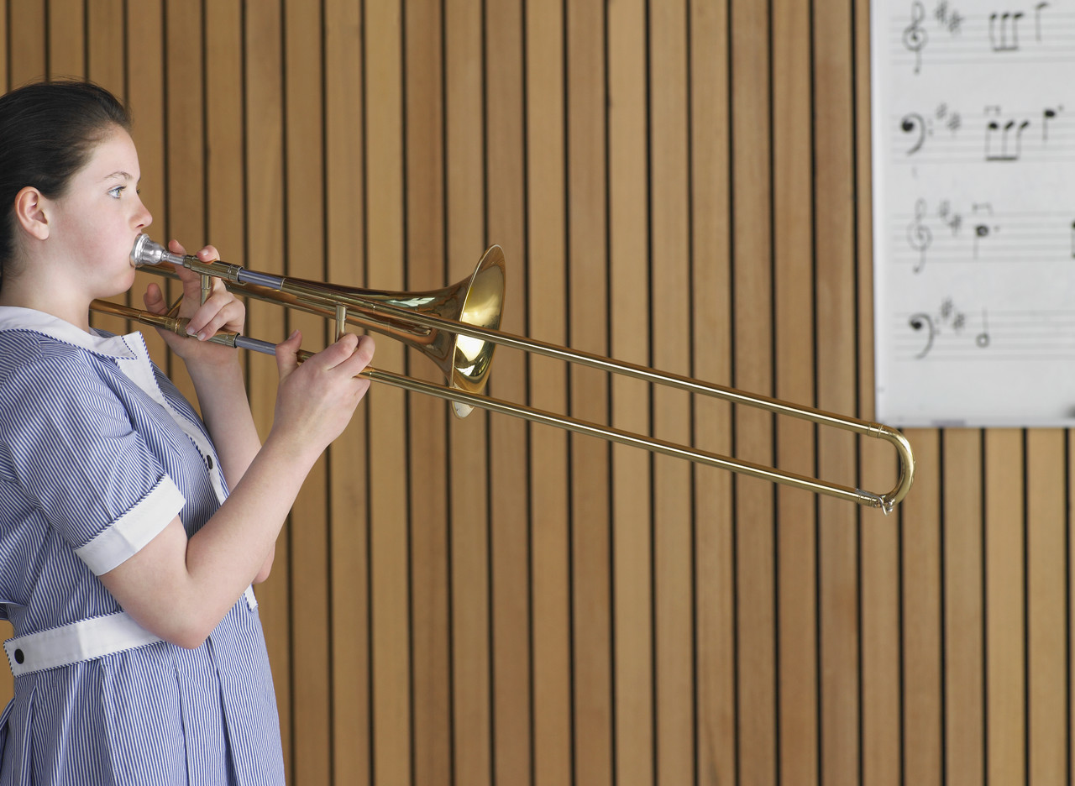

**A WORD FROM DAVID LOFTUS, YOUTH BAND MD**

In the last newsletter I wrote that a number of the Youth Band were looking forward to going to the Royal Albert Hall to watch the National Brass Band Championships. We had a very enjoyable day hearing some of the top bands in the country. It is hoped that we will do this again in October when I have a colleague who is conducting one of the competing bands.

We fulfilled our series of Christmas engagements and played at a new venue, Sunrise Home, Godalming, as well as performing at the various regular venues.

When we returned after the Christmas and New Year holiday it was straight in for the Godalming Music Festival preparations and we were not disappointed. We gained First placings in: Band Open, Entertainment and the Brass Quartet as well as collecting the John Boot Trophy. So it was a good evening’s work!!

The first of our Summer engagements was at The Burys Spring Fair where we were pleased to have our new vertical banner on display. This, plus our A boards and advertising, should help to locate us when we are performing as well as giving contact information for anyone interested in joining the Band.There are a number of engagements in the diary – including on June 4th performing alongside The Pepperpot as part of HM Queen Elizabeth’s Diamond Jubilee.

Amongst those who have sat Associated Board of the Royal Schools of Music examinations since the last newsletter are:

Lizzie - Distinction Grade 5 Eb Tenor Horn

Isabel (Davis) - Merit Grade 2 Bb Cornet

Matthew - Grade 6 Cornet

Danny – Distinction Grade 5 Baritone

Joel - Grade 2 Tenor Horn

Alex - Merit Grade 6 Tenor Horn

Well done to them all and anyone else who was successful in their musical examinations.

Three of the Youth Band spent a day during the Easter Holiday working on Theory so that they can sit the ABRSM Grade 5 Theory Exam and then progress with Practical Grades beyond Grade 5.

Presently there are 32 members of the Youth Band with average attendance at rehearsals being 28, which shows great commitment by Youth Band members as well as parents and others who assist in ferrying them around.

The “Jewel in the Crown” of our 40th Celebration of Godalming Youth Band will be the professional production of a CD, which we hope will be available in time for Christmas. It will mean some hard work but we hope the result will be something of which we can be proud.

David E Loftus, Youth Band Musical Director

**Solo Cornets** **Solo Horn** **1st Baritone** **Euphonium**

Theo Alexander Danny Ben (Beresford)

Caleb **1st Horn** **2nd Baritone** Charles

Laura Lizzie Mattie **Eb Bass**

Matthew **2nd Horns** Patrick Sam (Lowe)

Joel Jordan

Eliot

Jacob Tully (August)

**Repiano Cornets**

Jonathan **Trombones** **Percussion**

Isabel Sam (Warner) William

Isobel Ben (Bessemer) Jacob (Davis)

**2nd Cornets** **3rd Cornets**

Naila Ned

Maddie Lauren

Callum Hugh

Oliver

**C:\Users\David\AppData\Local\Microsoft\Windows\Temporary Internet Files\Content.IE5\TPINUGU4\MC900096113[1].wmf**

Top of Form

**COMING SENIOR BAND ENGAGEMENTS, 2012**

**This will be a very busy Summer and Autumn. You are cordially invited to all of these events.**

Sunday, 3 June Songs of Praise, Godalming Bandstand 5:30 -7 pm

Monday, 4 June Queen’s Jubilee Celebrations Godalming

Saturday, 16 June Shamley Green Village Fete 2-4 pm

Saturday, 16 June Church Crookham Fete 2-4 pm

Sunday, 1 July Wonersh United Reformed Church Songs of Praise 6:30 pm

Saturday, 7 July Cranleigh Fete 2-4 pm

Sunday, 8 July Pond Service, Hascombe 6 pm

**75th Anniversary events**

Saturday, 14 July All bands play in town 11 am-1 pm

Saturday, 14 July Joint Concert, with Joigny and Mayen bands, Ben Travers Theatre, Charterhouse 7:30 pm

Sunday, 15 July Joint Street Parade and Concert, Godalming Bandstand 5:30 pm

Saturday, 15 September Last Night of the Proms, Godalming Bandstand 5:30 pm

Sunday, 7 October Mayoral Service, Godalming Parish Church 10 am

Sunday, 21 October Mayor of Waverley Charity concert, Charterhouse pm

Sunday, 11 November Remembrance Day parade and service 10:00 am- 1 pm

Saturday, 24 November Christmas Lights switch-on, Godalming 4 pm

**Malcolm Gay**

We learned with much sadness of the sudden death of Malcolm Gay, musical director of the Slinfold Wind Band. Malcolm was Godalming Band’s musical director between 1976 and 1982 and is remembered for his enthusiasm as a conductor and compere. Under his leadership the band produced its first recording, a 12” vinyl LP.

Last October Malcolm and the Slinfold Band joined us for the Rotary Charity Concert at Charterhouse, when we enjoyed the fun of a ‘Conductors’ Duel’ between him and David Wright.

Malcolm will be greatly missed by everyone on the local musical scene. An obituary appeared in the **Surrey Advertiser** on 18 May.

.

**100 CLUB**

Over the last decade the Band’s 100 Club monthly draw has raised more than £3,000. This money has been used to buy instruments for the Senior and Youth Bands. Participation costs £1 per square per month or £12 per square p.a. - some squares are still for sale this year up until December. Funds are split between prizes and Band support. With your help, we hope to increase participation in the draw. Your name could be added to the monthly winners listed below, and the odds of winning are very favourable – just ask the Gordon-Smiths! For more information please contact us by e-mail, [annheward@yahoo.co.uk](mailto:annheward@yahoo.co.uk) or look at our website, **www.godalmingband.org.uk**

**100 CLUB WINNERS, 2011/2012**

**First Prize Second Prize**

November Margaret Lloyd Wendy Marshall

December David Sargeant Roger Humphrey

£306.50 was raised in 2011 – thanks to all

January – no draw. New draw began in February

February Alcroft family Cathy Gordon-Smith

March George Robins Tony Gordon-Smith

April Phil/Eve Kingsbury Mr R Godsen

If you would like to join the **Godalming Band’s Patrons’ Scheme** we would be pleased to hear from you. For just £10 per year we will keep you informed about the Band’s activities. The patrons’ scheme also supports the activities of the Youth Band. For more information please contact us by email,[annheward@yahoo.co.uk](mailto:annheward@yahoo.co.uk) or view our website.

**www.godalmingband.org.uk**

